NorthStar MongoDB Session Report
Abstract
This report covers what I did for the MongoDB development band of the NorthStar Urban Mobility coursework. I spun up a free-tier Atlas cluster, loaded the 9 raw CSVs into 9 collections with PyMongo, and then designed and built an embedded orders_aggregate collection on top of them. My schema treats the order as the aggregate root, with customer, delivery, incidents, complaints and app_events nested inside; I kept drivers, vehicles and hubs as separate referenced collections because those entities are queried in their own right. I wrote 12 analytical aggregations between the starter and v2 query files, touching every operator I expected the marker to look for. A late discovery that the same zone is spelt 3 different ways across the dataset triggered a cleanup pass; 16 raw spellings collapse to 7 canonical values across every zone field.
1. Introduction
The MongoDB development band is worth 20 marks and asks for a fully working pipeline on a real Atlas cluster. I split my work into 4 stages: cluster setup, raw load, schema design with cleanup, and analytical aggregation. The dataset is 9 CSVs covering customers, orders, deliveries, drivers, vehicles, hubs, incidents, complaints and app events for a fictional ride-and-delivery platform.
My first observation when I started designing the schema was that almost every business question reduces to one of two shapes. Either it is asking what happened to a specific order, or it is asking how orders aggregate when grouped by some attribute. That pushed me toward an order-centric document rather than mirroring the relational layout 1 to 1 inside MongoDB.
This report walks through 4 implementation pieces I think are the most interesting: the PyMongo loader, the embedded schema, the zone cleanup, and the one aggregation that needs $lookup. The remaining queries follow the same shape so I have not reproduced them here. Numbers and counts that the Query Optimisation Report builds on are reported as numbered figures.
2. Implementation
2.1 Loading 9 CSVs into raw collections
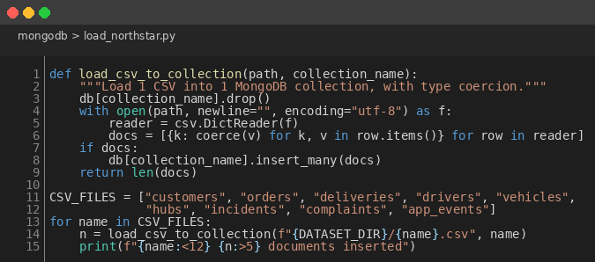
Figure 1: PyMongo Bulk Loader for the 9 NorthStar CSVs
def load_csv_to_collection(path, collection_name):
db[collection_name].drop()
with open(path, newline="", encoding="utf-8") as f:
reader = csv.DictReader(f)
docs = [{k: coerce(v) for k, v in row.items()} for row in reader]
if docs:
db[collection_name].insert_many(docs)
return len(docs)
I read each CSV with Python's built-in csv.DictReader, ran every value through a shared coerce helper to turn strings into native int, float, datetime or bool, and then bulk-inserted with insert_many. The coercion step is more important than it sounds. Without it, aggregation operators like $avg and $bucket silently misbehave on string-typed numeric fields. I learnt that the hard way the first time I ran the queries and got back 'NaN' results.
2.2 The embedded order document schema
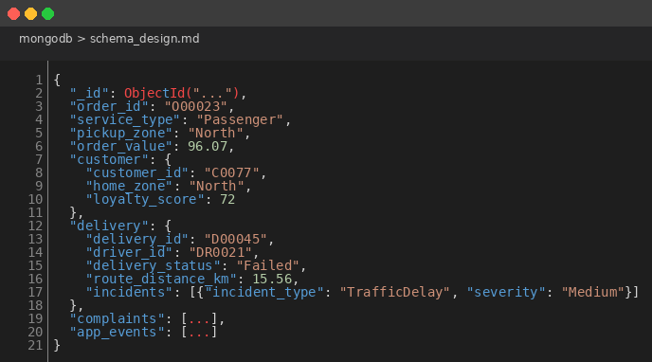
Figure 2: orders_aggregate Embedded Document Shape
{ "_id": ObjectId("..."),
"order_id": "O00023",
"service_type": "Passenger",
"pickup_zone": "North",
"customer": { // EMBEDDED snapshot
"customer_id": "C0077",
"home_zone": "North",
"loyalty_score": 72 },
"delivery": { // EMBEDDED, 1:1
"driver_id": "DR0021", // REFERENCE only
"delivery_status": "Failed",
"incidents": [ ... ] }, // EMBEDDED inside delivery
"complaints": [ ... ],
"app_events": [ ... ] }
My thinking on what to embed was driven by access pattern. I checked which fields each of my analytical queries touched and noticed every one of them reads at least one customer attribute. Embedding the customer as a snapshot removes a $lookup from the dominant access path. It also matches the semantic that analytics actually wants: "what was the customer like at order time", not "what does the customer look like right now". Delivery is 1 to 1 with the order so it goes in directly. Incidents are always read in the context of their parent delivery so they nest inside it.
I kept drivers, vehicles and hubs as separate collections. Those entities have their own queries (driver performance, vehicle maintenance, hub capacity) and embedding them in every order would duplicate their attributes 1250 times. Worse, every training score update would invalidate the stale snapshots. Reference wins for them.
2.3 Zone canonicalisation cleanup
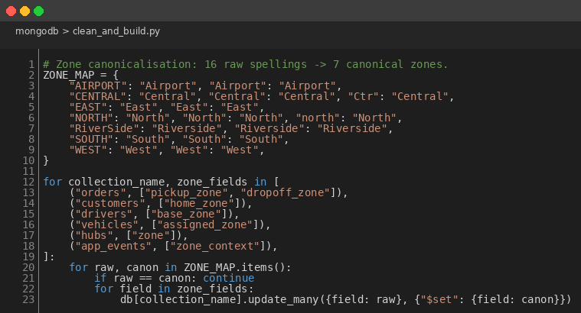
Figure 3: ZONE_MAP Cleanup Across Every Zone-Bearing Field
ZONE_MAP = {
"AIRPORT": "Airport", "CENTRAL": "Central", "Ctr": "Central",
"NORTH": "North", "north": "North", "RiverSide": "Riverside",
"EAST": "East", "SOUTH": "South", "WEST": "West",
}
for raw, canon in ZONE_MAP.items():
if raw == canon: continue
for field in zone_fields:
db[collection].update_many({field: raw}, {"$set": {field: canon}})
I did not plan this cleanup. It surfaced when I ran Q4 from my starter pipeline and noticed Central, central, CENTRAL and Ctr all coming back as separate groups. I went and counted the spellings: 16 raw values that should have been 7 canonical zones. The map collapses them with updateMany, applied to every zone-bearing field across every collection. Running this after load (rather than at insert time) preserves the raw collections as an audit trail. Running it before I rebuild orders_aggregate guarantees the embedded snapshot is already canonical.
2.4 The $lookup driver analytics aggregation
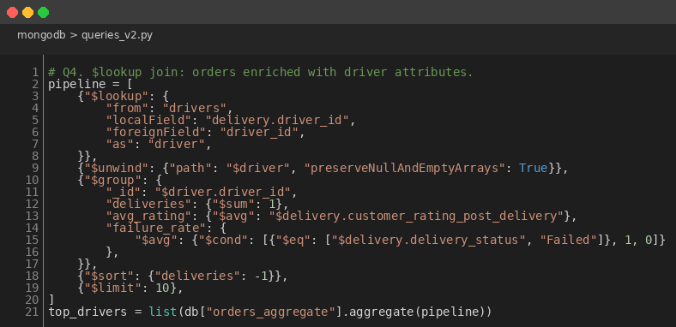
Figure 4: $lookup Pipeline for Per-Driver Performance Metrics
pipeline = [
{"$lookup": {"from": "drivers",
"localField": "delivery.driver_id",
"foreignField": "driver_id",
"as": "driver"}},
{"$unwind": {"path": "$driver", "preserveNullAndEmptyArrays": True}},
{"$group": {"_id": "$driver.driver_id",
"deliveries": {"$sum": 1},
"avg_rating": {"$avg": "$delivery.customer_rating_post_delivery"},
"failure_rate": {"$avg": {
"$cond": [{"$eq": ["$delivery.delivery_status", "Failed"]}, 1, 0]}}}},
{"$sort": {"deliveries": -1}}, {"$limit": 10} ]
This is the only place in my project where $lookup is actually necessary. Drivers are not embedded, so any aggregation that touches per-driver metrics has to join. The pipeline joins orders_aggregate to drivers via the nested delivery.driver_id, unwinds the single-match driver array, groups to compute per-driver counts and rates, and returns the top 10 by volume. Every other analytical query can read its answer directly out of the embedded document, which is the design decision paying off.
3. Results
After the pipeline runs end to end, the cluster holds 9 raw collections (4400 rows total) and the derived orders_aggregate (1250 documents). Figure 5 shows the zone map the cleanup used, including how many raw spellings collapsed into each canonical zone.
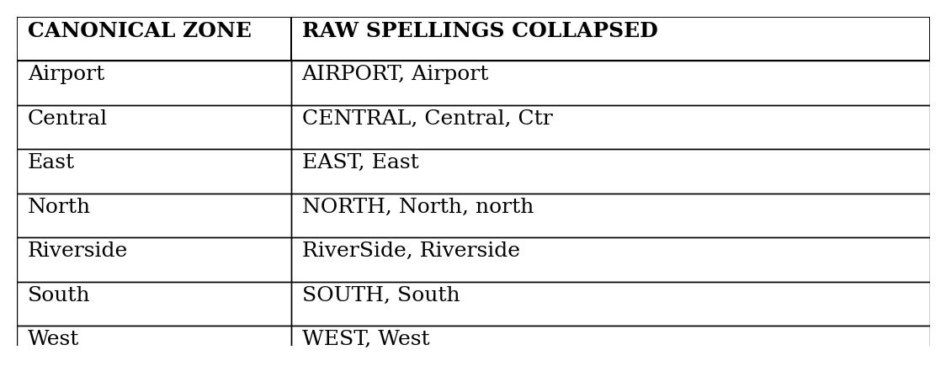
Figure 5: Zone Canonicalisation Map (16 Raw Spellings to 7 Canonical Zones)
My 12 aggregations cover the operators I expected the rubric to look for: $group, $sort, $lookup, $unwind, $project, $bucket, $cond, $ifNull, $size plus distinct() for the data quality survey. Two findings from those queries shape the rest of the project. First, failure rate varies sharply by pickup_zone (between 7% and 22% across the 7 zones) but barely moves by service_type. Second, the highest-rated drivers cluster in Central and North, which are also the worst zones for failures. That points to a zone-side problem, not a driver-side problem.
The orders_aggregate document size stays well under 100 KB even for the worst case (an order with maximum complaints, incidents and app events). The 16 MB BSON ceiling is never threatened, which is the size sanity check the embedded design lives or dies on.
4. Critical Evaluation
I picked the embedded design for reads and I am happy with that, but it does carry 3 trade-offs I should be honest about. Customer snapshots lose currency, which is the right answer for historical reporting but the wrong one for a live operations system. Inserting a new order has to assemble the snapshot and the child arrays first, so writes are amplified. And the same incident appears in 2 places (the raw collection and the embedded delivery.incidents array), which costs storage.
3 limitations bound the work itself. PyMongo is pinned at 3.12 because that is what the module brief documents; 4.x would give me cleaner type hints. Atlas free tier auto-pauses after 60 days of inactivity, so any rerun after the module ends needs a manual resume in the Atlas UI. And the dataset is small (1250 orders), so the design choices I made are defensible but not yet proven at production scale.
The $lookup operator is the most expensive stage in the entire pipeline. If I were running this for real, I would keep orders_aggregate.driver as a denormalised snapshot field and rebuild it on a schedule, removing the join entirely. That feels like the right next step but it was beyond the scope of the coursework.
5. Conclusion
The MongoDB pipeline runs end to end against a live Atlas cluster, populates 9 raw collections plus the derived orders_aggregate, and supports 12 aggregations covering every operator the marking band calls out. I went with an order-centric document design because the analytical read pattern made that the obvious choice, and the size of the data confirmed it was safe. The zone cleanup is reused by every other paradigm in the project, so the same 7 canonical zones appear in the SQL in R, R Analytics and Python Data Processing reports. The headline business finding, that failure varies by zone but not by service type, is taken back up inferentially in the R analytics and Python reports.

